Session manager

Requirement

1. Need to add role which have ssmcoreaccess
2. Instance should connect with systems manager .

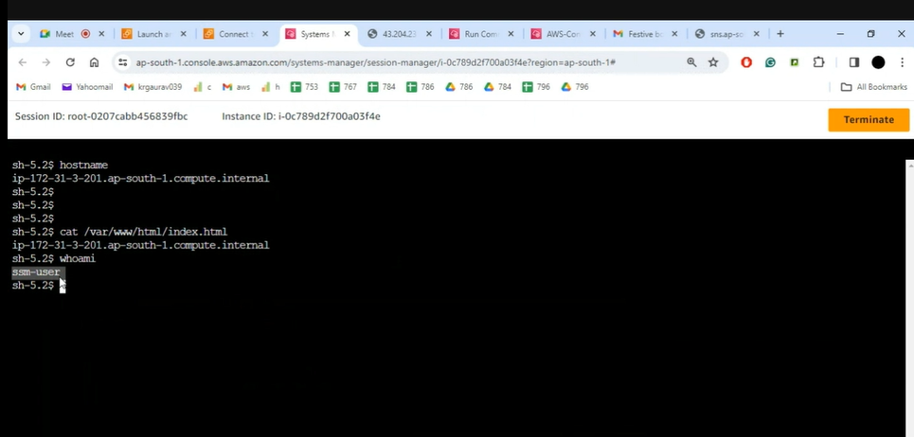

We are connecting ec2 without putty , key , without port